Chapter 10 Exercises
Add constraints and an index to the AP schema
- Write an ALTER TABLE statement that adds two new check constraints to the Invoices table of the AP schema. The first should allow (1) payment_date to be null only if payment_total is zero and (2) payment_date to be not null only if payment_total is greater than zero. The second constraint should prevent the sum of payment_total and credit_total from being greater than invoice_total.
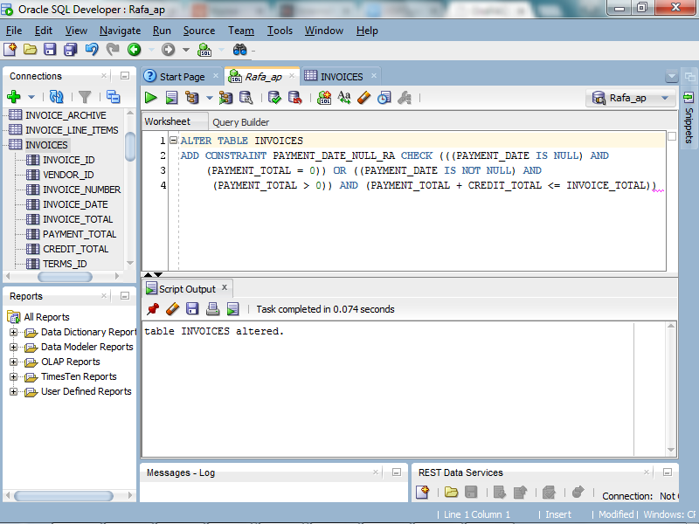

- Add an index to the AP schema for the zip code field in the Vendors table.
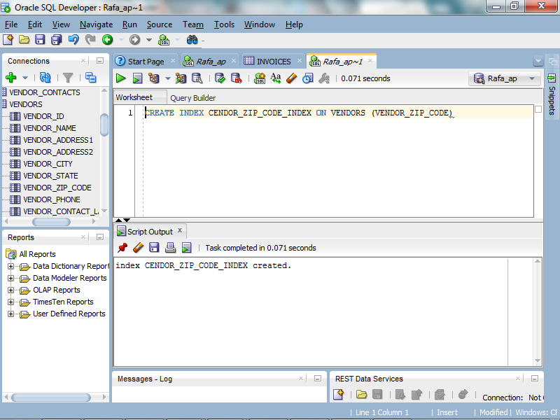

Implement a database design
- Write the CREATE TABLE statements needed to implement the following design in your schema:
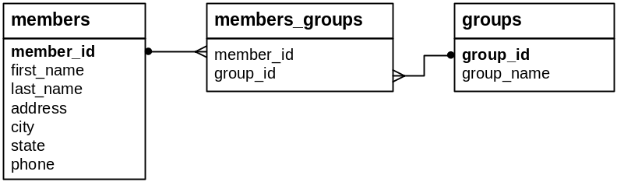
These tables provide for members of an association, and each member can be registered in one or more groups within the association. There should be one row for each member in the Members table and one row for each group in the Groups table. The member ID and group ID columns are the primary keys for the Members and Groups tables. And the Members_Groups table relates each member to one or more groups.
When you create the tables, be sure to include the key constraints. Also, include any null or default constraints that you think are necessary.
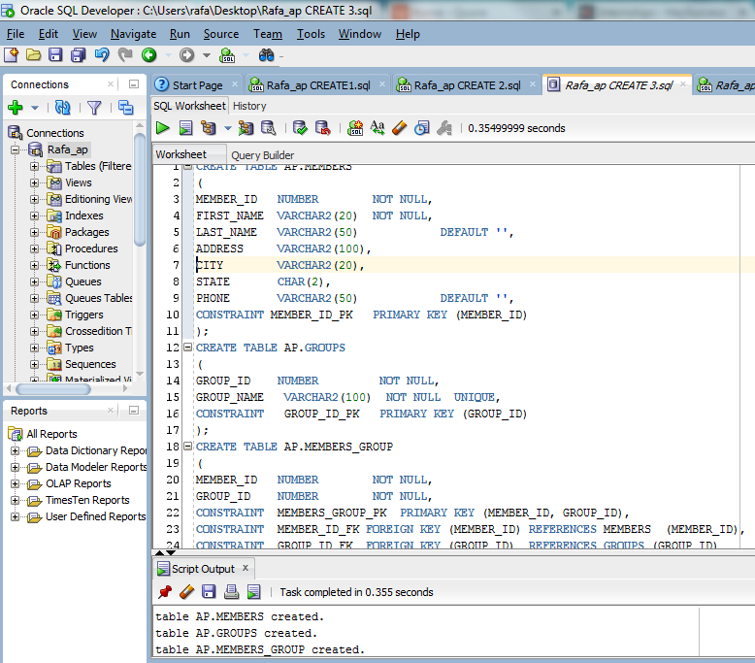

- Write INSERT statements that add two rows to the Members table for member IDs 1 and 2, two rows to the Groups table for group IDs 1 and 2, and three rows to the Group_Membership table: one row for member 1 and group 2; one for member 2 and group 1; and one for member 2 and group 2. Then, write a SELECT statement that joins the three tables and retrieves the group name, member last name, and member first name.
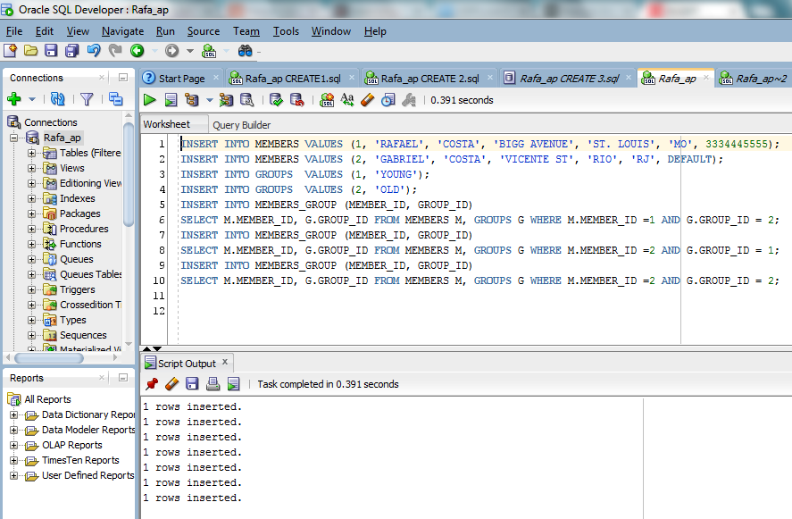

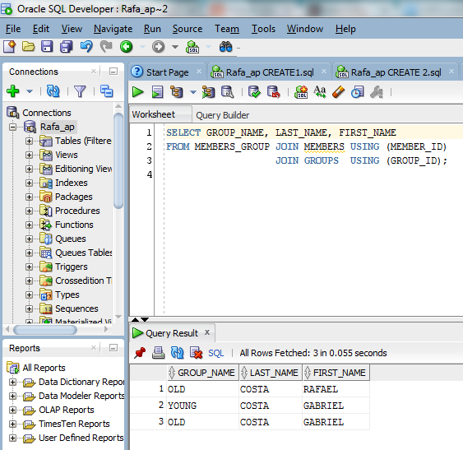

- Create sequences that can be used to number the member ID and group ID values starting with 3 (since you already added members and groups for IDs 1 and 2).
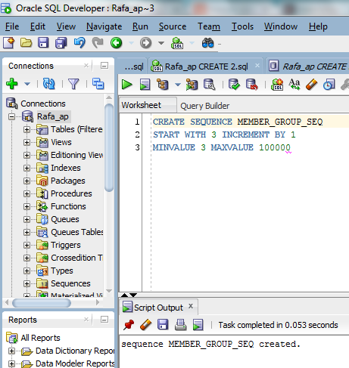

- Write an INSERT statement that adds another row to the Groups table. This statement should use the NEXTVAL pseudo column to get the value for the next group ID from the sequence that you created in exercise 5. Then, write a SELECT statement that gets all of the data for all of the rows in the Groups table to make sure your sequence worked correctly.
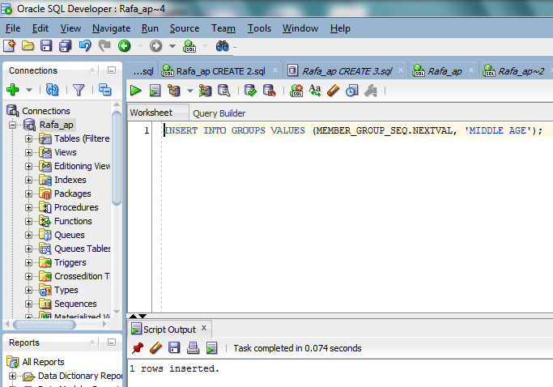
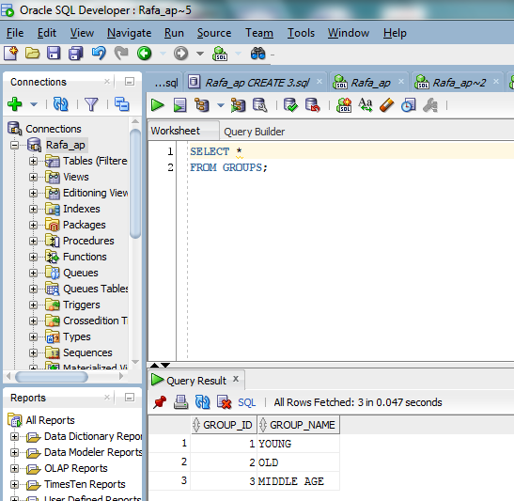

- Write an ALTER TABLE statement that adds two new columns to the Members table: one column for annual dues that provides for three digits to the left of the decimal point and two to the right; and one column for the payment date. The annual dues column should have a default value of 52.50.
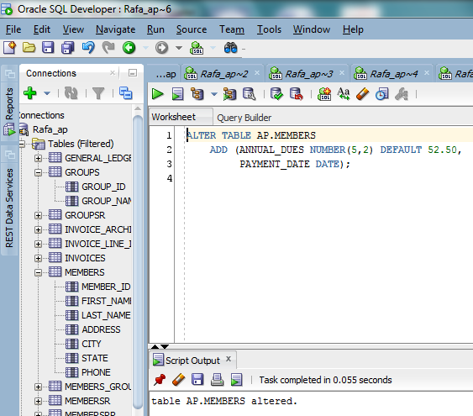

- Write an ALTER TABLE statement that modifies the Groups table so the group name in each row has to be unique. Then, re-run the INSERT statement that you used in exercise 6 to make sure this works.
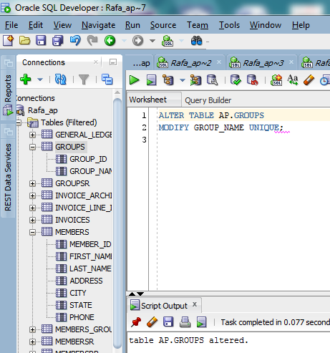

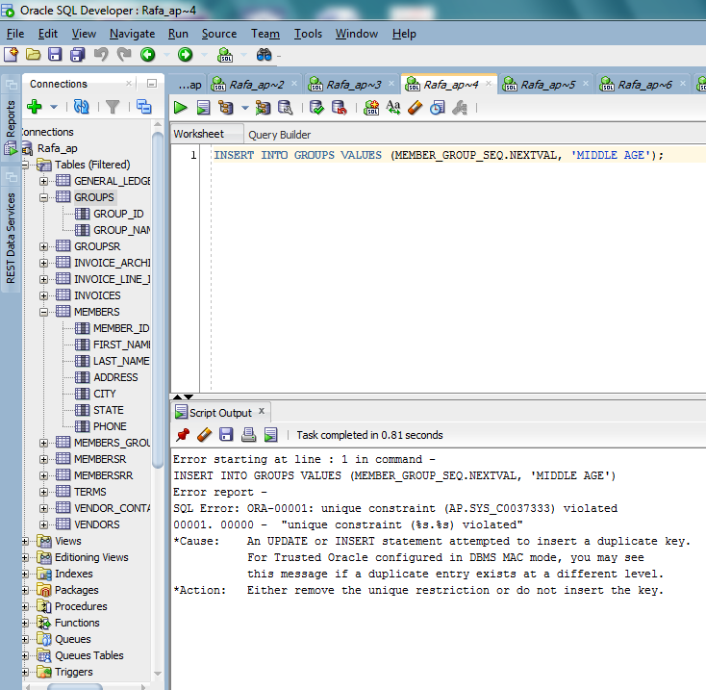

Chapter 11 Exercises
1. Create a view that defines a view named open_items that shows the invoices that haven’t been paid. This view should return four columns from the Vendors and Invoices tables: vendor_name, invoice_number, invoice_total, and balance_due (invoice_total – payment_total – credit_total). However, a row should only be returned when the balance due is greater than zero, and the rows should be in sequence by vendor_name. Then, run the script to create the view, and use SQL Developer to review the data that it returns. (You may have to click on the Refresh button in the Connections window after you click on the Views node to show the view you just created.)
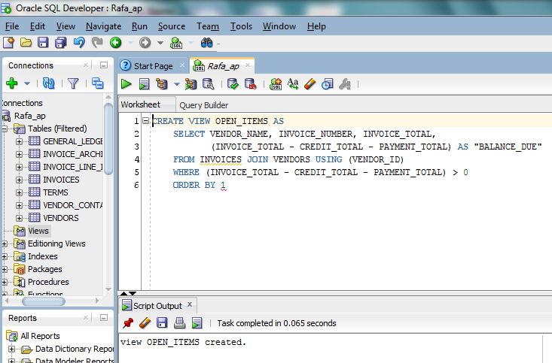

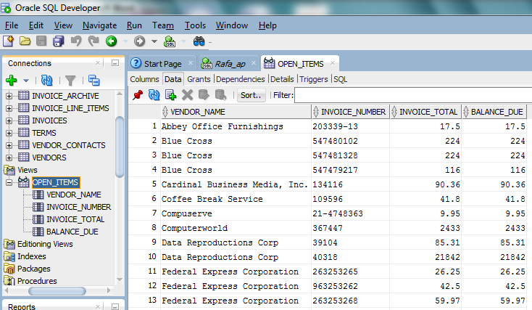

2. Write a SELECT statement that returns all of the columns in the open_items view that you created in exercise 1, with one row for each invoice that has a balance due of $1000 or more.
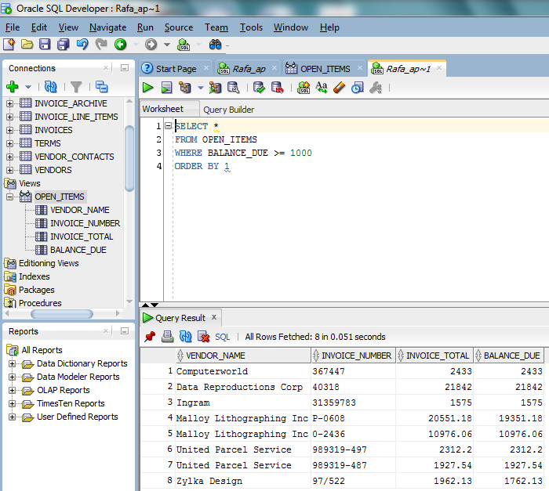

3. Create a view named open_items_summary that returns one summary row for each vendor that contains invoices with unpaid balance dues. Each row should include vendor_name, open_item_count (the number of invoices with a balance due), and open_item_total (the total of the balance due amounts), and the rows should be sorted by the open item totals in descending sequence. Then, run the script to create the view, and use SQL Developer to review the data that it returns.
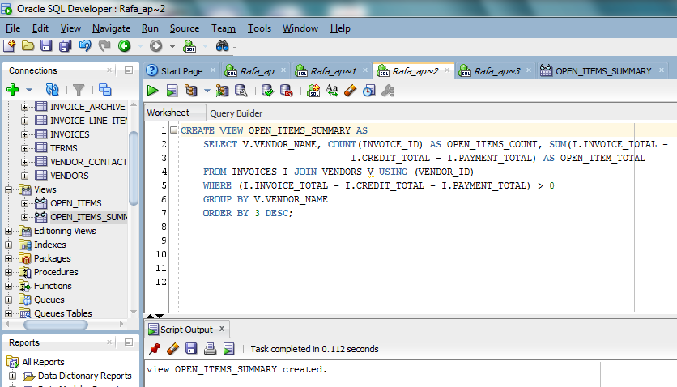
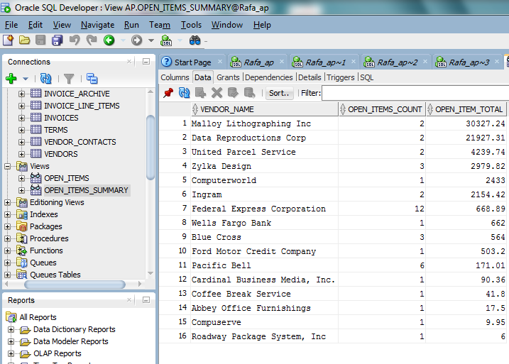
4. Write a SELECT statement that returns just the first 5 rows in the open_items_summary view that you created in exercise 3.
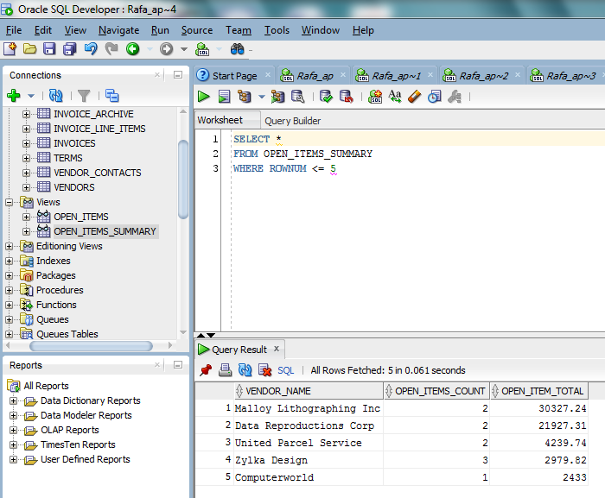

5. Create an updatable view named vendor_address that returns the vendor_id, both address columns, and the city, state, and zip code columns for each vendor. Then, use SQL Developer to review the data in this view.
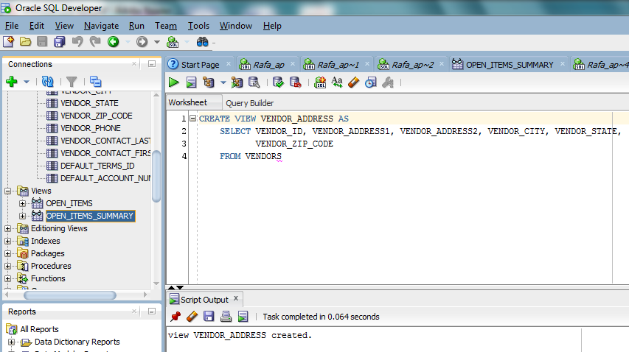
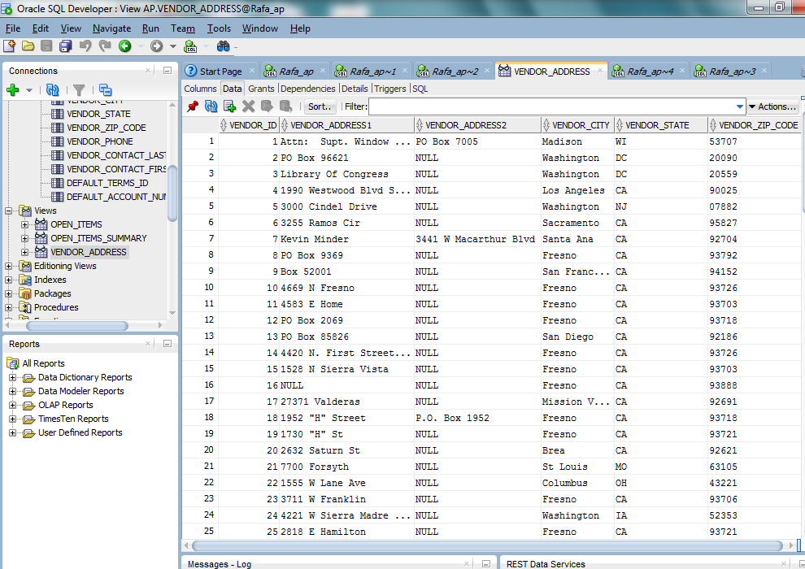
6. Write an UPDATE statement that changes the address for the row with vendor ID 4 so the suite number (Ste 260) is stored in vendor_address2 instead of vendor_address1. Then, use Oracle SQL Developer to verify the change (you may need to click the Refresh button at the top of the Data tab to see the change). If this works correctly, go back to the tab for the UPDATE statement and click the Commit button to commit the change.
